One of the distinguishing features of the boxes-and-arrows diagram is that it highlights the major sources of input and output in the system. This is in marked contrast with most programming languages where the I/O functionality is buried deep within the code itself. For example, our splitComponent does not directly communicate with a database; instead it poses a query to the partsDB component. Similarly, the components for recovering incoming orders and sending out orders to suppliers are mostly about implementing the appropriate I/O operations.
The partsDB component is interesting for another reason: it can be modeled as an adapter to a normal database engine. In fact, the partsDB is quite an interesting component.
Consider the problem of the partsDB component: if we are to build this component in a robust fashion then it must respond to arbitrary queries about the two relations that are exposed in its responding port. However, we assume that the data it uses to answer those queries is not ‘in’ the component itself but is stored in some actual database; perhaps an SQL database.
In order to see how we can achieve this we need to look a little deeper into how speech actions are actually represented. Recall that we stated that a speech action requires an entity that implements the speech contract. That contract, in simplified form, is:
<$Scr_Ps::0>contract all t,a ~~ speech[t->>a] ::= {
_query:all s ~~
(t,(a)=>s,()=>quoted,()=>dictionary[string,quoted])=>s.
_request:
(t,(a)=>(),()=>quoted,()=>dictionary[string,quoted])=>().
_notify:(t,(a)=>())=>()
}
<!$Scr_Ps::0>The actual contract is somewhat more involved and involves the use of the execution contract – which is part of the support for Star’s concurrency features. However, this variant is sufficient for us to expose the required issues.
The salient element here is the entry for _query. A speech action like:
<$Scr_Ps::0>query parts with list of { unique S where
(A,Ps) in assembly && P in Ps &&
(P,Ss) in supplier &&
S in Ss
}
<!$Scr_Ps::0>is translated – by a standard built-in macro processor – into a call to _query of the form:
<$Scr_Ps::0>_query(parts,
(Ax)=>list of { unique S where
(A,Ps) in Ax.assembly && P in Ps &&
(P,Ss) in Ax.supplier && S in Ss },
()=><|list of { unique S where
(A,Ps) in assembly && P in Ps &&
(P,Ss) in supplier && S in Ss
}|>,
()=>["A"->A::quoted]
)
<!$Scr_Ps::0>This is kind of complicated to follow at first; but is quite straightforward if taken one step at a time.
- The first argument to _query is the entity being queried with the query speech action. The structure of the speech contract allows a responder to a speech action to ‘pass on’ the action to another responder.
- The second argument is the expression that must be evaluated by the actual responding entity. It is encapsulated in a single argument function – the argument being a record that implements the speech action API. Evaluating this function in the appropriate context has the effect of computing the response to the query speech action – and the result of the function is returned as the value of the query speech action itself.
- The third and final arguments are used when the responder cannot or does not wish to use the ‘compiled query’. The third argument is a function that returns the original ‘text’ of the query – as a quoted value. The expression: <|list of { unique S where (A,Ps) in assembly && P in Ps && (P,Ss) in supplier && S in Ss }|> has, as its value, an AST term – of type quoted. This form allows a receiver of the request to inspect the query and determine for itself how to interpret it. This is analogous to applications processing queries expressed in terms of Json or XML; except here we allow Star’s syntax.
- The fourth argument is also a function, one that returns the values of any free variables in the query – variables whose values are determined by the context of the speech action itself. In this case there is only one free variable – A – which was the part that our splitComponent needed to find suppliers for.
This arrangement allows for two kinds of speech action processing: if the respondent trusts the originator of the speech action then a very rapid response to the query is possible – by evaluating the embedded function. However, in the case where the respondent does not want to simply execute the query function, or it cannot, then the respondent has access to the original text of the query – together with the values of any free variables that appear in the query.
In the case of the partsDB component it cannot simply trust the query; even if it wanted to. This is because the query must be mapped into a form that the attached SQL database can understand. In effect, the query must be translated from Star’s query language to SQL.
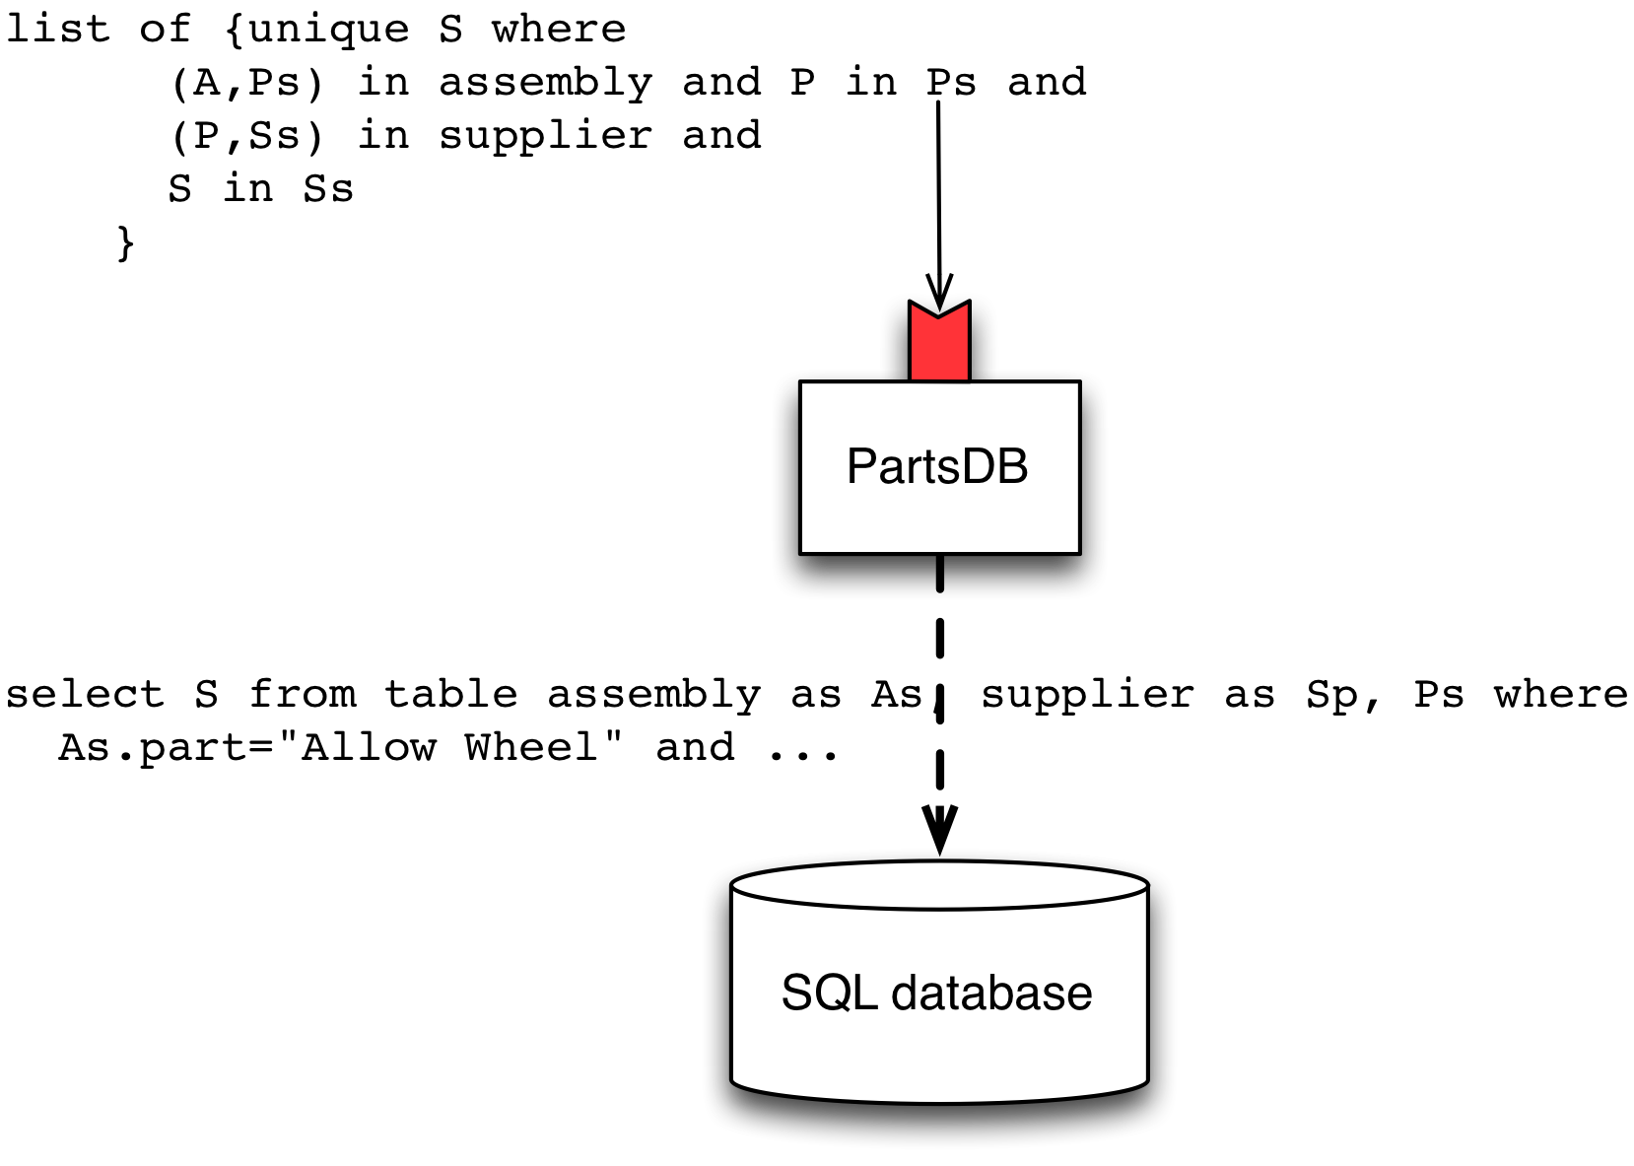
<$Scr_Ps::1>The PartsDB Component
<!$Scr_Ps::1>I.e., the query expression is translated by the partsDB component into SQL:
select S from table assembly as As, supplier as Sp, Ps, Ss where
As.part="Alloy Wheel" and Ps.partno=As.partno and
Ps.supplier = Sp.id and
Ps.supplier=Ss.id and Ss.supplier=S
The details of how this translation are achieved are beyond the scope of this book; but it involves similar techniques to those we saw in [our chapter on DSLs][application-policy-mechanism].
One important point to note here is that the machinery for translating queries into SQL is quite general; and not at all restricted to our parts database. In fact, if we provide the actual database component with a URL of the database we are interested in, the DSL processor is able to dynamically inspect the actual database, construct the appropriate responder port for the partsDB component as well as being able to answer queries by mapping them to SQL.
As a result, we can construct a general purpose adapter component that is able to be used for any database, not just the one we are using in this application. The result of which is that the application is populated with a mixture of standard components that are configured and specifically written components that implement the specific functionality of the application.

